Lab3

Basic Logic Gates: AND, OR, and NOT

By: Brandon Kowal, Bernard Owusu Sefah

Abstract

In the lab we developed a circuit starting with the SN7493. Than we used the SN7408, SN7432, and SN7404 ICs to show the fundamental logic gates of AND, OR, and NOT. Each IC had one of the gates and had a pinhole layout to 1 and 2 were inputs and 3 was the output. When the circuit was complete we were able to show the correct truth table.

Introduction

This Lab will show the basic logic gates AND, OR, and NOT. Than the truth tables will be verified with the experiment. The lab will use the 408, 432, and 404 ICs and the pin layout for each gate will be studied.

Methods

1. For task 1 we first constructed a circuit on the protoboard using a logic gate on the IC and connecting its Vcc to +5V and to the common ground through the ground pins.

2. We then connected the mso channels to the respectively inputs x, y and z to the logic gate.

3. Set the frequency to 1Khz and set the triggers to 00 then hit the single key.

5. For task 2 we verified the Boolean expression x, y and z using the mso.

6. Finally we had to draw a truth table and compare it to the experimented simulation to figure out if they matched.

Results

Fig 1.

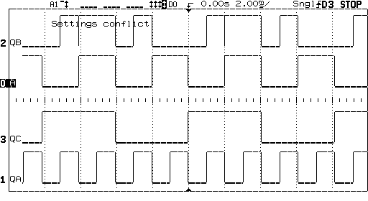

Fig 2

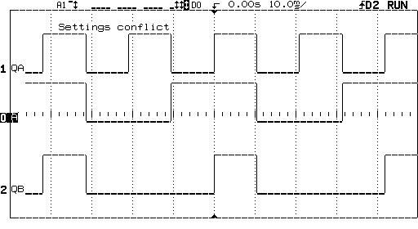

Fig 3

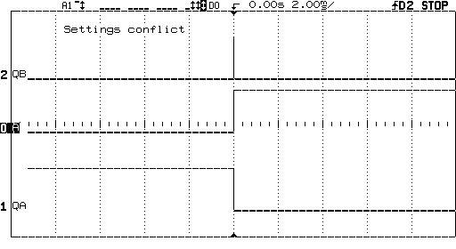

Discussion

This lab was to focus on learning the AND, OR, and NOT gets. The AND gate will multiply the inputs, so a 1 and 0 would output to a 0. The OR gate adds the inputs, so a 1 and 0 would output to a 1. The NOT gate will flip-flop so a 1 will flip to a 0 and a 0 will be a 1. All three of these gates were used in this circuit.

Conclusion

We were able to use all the ICs in this logic circuit and helped us get a better understanding of the AND, OR, and NOT gates. We were able to get a correct truth table experimentally with the f (x, y, z) logic function.

Appendix

Lab Attendance: Bernard Owusu Sefah: Yes Brandon Kowal: Yes

Involvement in Lab: Bernard Owusu Sefah: 50 Brandon Kowal: 50

Involvement in Lab Report: Bernard Owusu Sefah: 55 Brandon Kowal: 45